
Work Instruction for Firmware Upgrade for Cisco Rack Servers

Viatris
Work Instruction for Firmware Upgrade for Cisco Rack Servers

Contents
Contents 2
1. Introduction 3
1.1. Purpose 3
1.2. Scope of this Report 3
1.3. Audience 3
2. Approach and Methodology 3
2.1. Approach 3
2.2. Methodology 3
3. Technical Details 4
3.1. Step 1 4
3.2. Step 2 5
3.3. Step 3 6
4. Roles and Responsibilities 8
5. Escalation Matrix 8
6. Related Documentation 8
6.1. Additional Documentation 8
7. Revision History 9

1. Introduction

1.1. Purpose
This document will provide the procedure to be followed while Firmware Upgrade for Cisco Rack Servers based on the requirement.

1.2. Scope of this Report
The purpose of this guide is to provide details on Firmware Upgrade for Cisco Rack Servers.

1.3. Audience
GIDC UNIX Group

2. Approach and Methodology

2.1. Approach

2.2. Methodology
2.2.1. login to the required firmware upgraded server using console Ip, and check the version plus add the image as virtual media.
2.2.2. Switch off & switch on the server,
Launch KVM console & while boot press F6.
    - Accept the agreement select required fields for firmware upgradation, after that check the firmware version.

Technical Details

3.1. Step 1
3.1.1. RDP to “w0bhosting001” server
Updated firmware 3.0(4d) is already downloaded.
3.1.2. login to respective media server using imm console ip.
Check the current firmware version of the server.

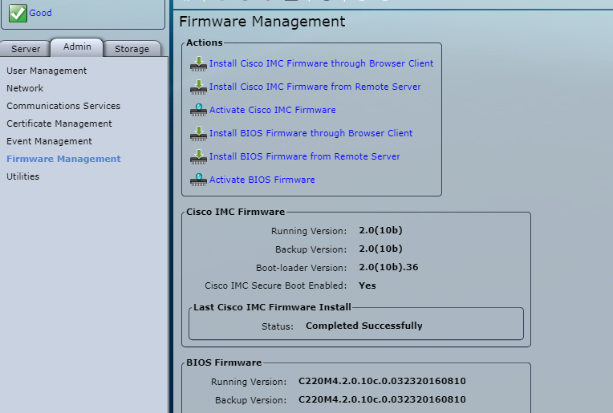

3.1.3. Add the downloaded huu image as virtual media.

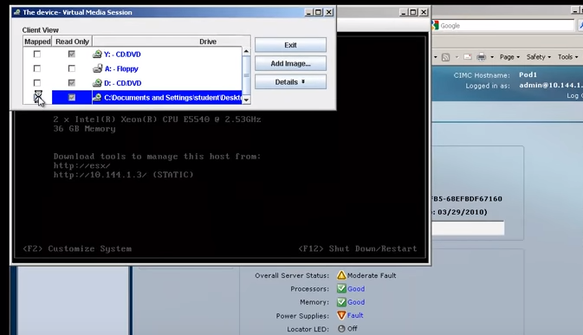

3.2. Step 2
3.2.1. power off the server.
3.2.2. power on and Launch KVM console.
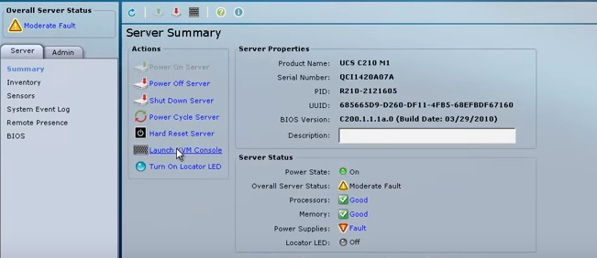

3.2.3. During server boot press F6
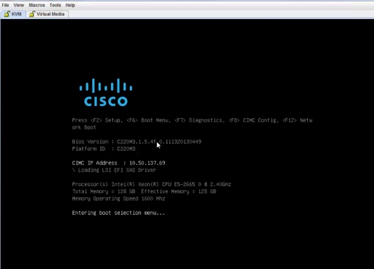

3.3. Step 3
3.3.1. Accept the license agreement.
3.3.2. select update all.
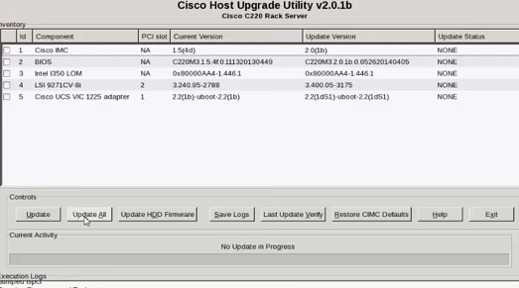
3.3.3. Select No, to begin firmware upgrade.
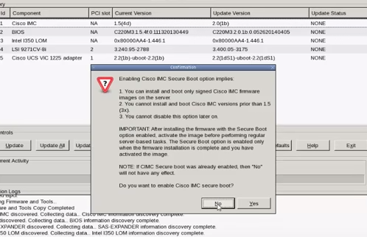

3.3.4. After firmware upgrade is completed, you will lose the connection login again and check the updated firmware version.

4. Roles and Responsibilities
Sl. No. | Roles | Responsibilities | Team Member Name
1. | Maintenance Window | Respective Team / Unix Team | GIDC.unix_Run  GIDC.unix_Run@viatris.com
2. | Change Request | Respective Team / Unix Team | GIDC.unix_Run  GIDC.unix_Run@viatris.com
3. | Change Implementation | Respective Team / Unix Team | GIDC.unix_Run  GIDC.unix_Run@viatris.com
4. | Hyper Care | Respective Team / Unix Team | GIDC.unix_Run  GIDC.unix_Run@viatris.com

5. Escalation Matrix
Person Responsible | Role | Triggers When
Arun R  Arun.R@viatris.com  +91 9710677240 | SME
Ashok Kumar R K  AshokKumar.RK@viatris.com  +91 9967735890 | Manager
Mohandoss Murugesan  Mohandoss.Murugesan@viatris.com  +91 6366966170 | Senior Manager

6. Related Documentation

6.1. Additional Documentation

7. Revision History
Date | Version | Summary of Changes | Author | Approved by
May 19 2021 | V 1.3 | Updated Organization Detail | Franklin Kabila Dhas | Arunachalam G
Apr 5 2023 | V1.4 | Updated in New Template | Ashok Kumar RK | Mohandoss Murugesan
Dec 28 2024 | V1.4 | Validated the Document | Benesh Selva Nesan P | Arun R

